Answers
1. A secondhand car dealer keeps a database of cars for sale. A sample of the data is shown below. The table below is named Cars.
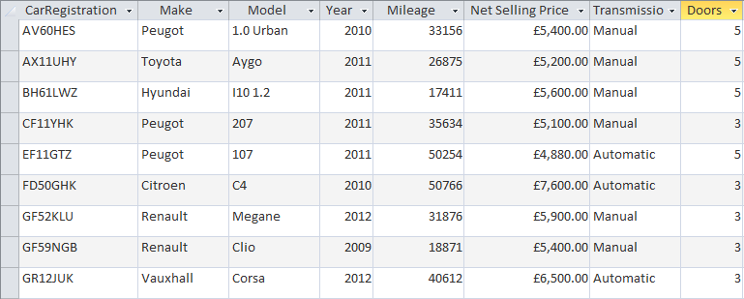
(a) State the registration number of the cars that will be found using each of the following criteria:
Mileage < 20000 [2]
BH61LWZ
GF59NGB
Year >= 2011 and Transmission = 'Automatic' [2]
EF11GTZ
GR12JUK
(Make = 'Peugeot' OR Make = 'Renault') AND (Net Selling Price <= 5200.00) [2]
CF11YHK
EF11GTZ
(b) Write the SQL statement which will display the registration numbers and make of
all cars with 5 doors made in 2011 or after. [3]
SELECT CarRegistration, Make
FROM Cars
WHERE Doors = 5 AND Year >= 2011

2. A school keeps a record of all the school trips that take place each school year. An extract from the table Trips is shown below:
Trip ID | Description | StartDate | EndDate | Destination | NumberOf Students
14 | DofE Gold Expedition | 09/04/2014 | 13/04/2014 | Wales | 30
15 | Year 7 Castles Trip | 01/05/2014 | 01/05/2014 | Framlingham | 87
16 | Year7 Geography Field Trip | 07/05/2014 | 07/05/2014 | Walton-on-the-Naze | 91
17 | Prefects Leadership weekend | 20/06/2014 | 23/06/2014 | Bradwell | 15
18 | Spanish Taster Trip | 26/06/2014 | 30/06/2014 | Santander | 27
(a) Write an SQL query to find all trips in the Trips table where the number of students going is greater than 60. The Results table should display the columns labelled Description, StartDate, EndDate, Destination and NumberofStudents.
Records should be sorted by the number of students in descending order. [4]
SELECT Description, StartDate, EndDate, Destination, NumberOfStudents
FROM Trips
WHERE NumberOfStudents > 60
ORDER BY NumberOfStudents DESC
(b) State which field will be the primary key in this table. [1]
Trip ID (1)
(c) Complete the table below to show suitable data types for each of the fields given. [3]
Field name | Data type
StartDate | Date/Time
NumberOfStudents | Integer
Destination | Text / alphanumeric
(d) The school has a capacity for 1000 students. No trip will ever go ahead with
more than this number of students.
Give a suitable validation for the NumberOfStudents field. [1]
<=1000
OR
BETWEEN 1 AND 1000
[Total 18 marks]

